*AFTER PUSHING ROUTINES, IF YOU SEE MERGE CONFLICT IN GERRIT (LIKE BELOW SCREEN SHOTS) FOLLOW BELOW STEPS TO RESOLVE.*

AFTER PUSHING ROUTINES, IF YOU SEE MERGE CONFLICT IN GERRIT (LIKE BELOW SCREEN SHOTS) FOLLOW BELOW STEPS TO RESOLVE.

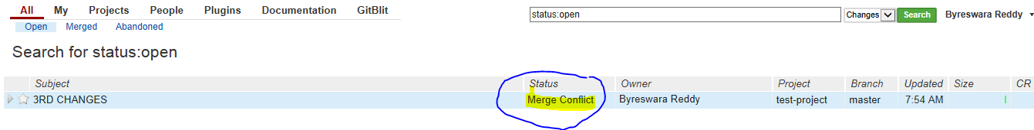

1. Click right button of mouse on ocean-lbg (check below screen shot) and select Fetch From Upstream

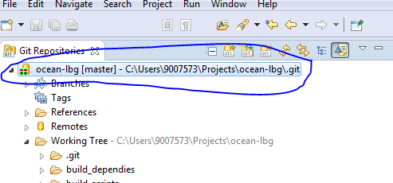

* It will fetch latest updates from remote repository like below screen shot.
* Click ok on popup window

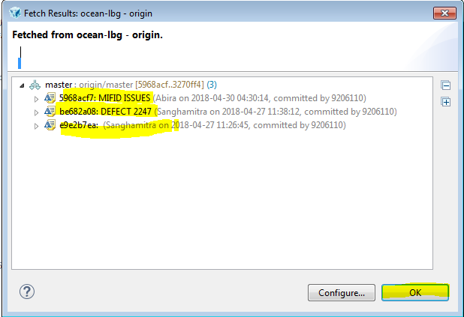

1. Click right button of mouse on ocean-lbg (check below screen shot) and select Rebase...



* Select origin/master and click on Rebase
* Click on Ok on popup window

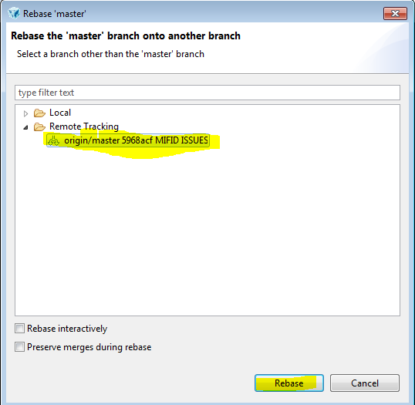

1. Check on DO nothing (return to the workbench) then click on Ok

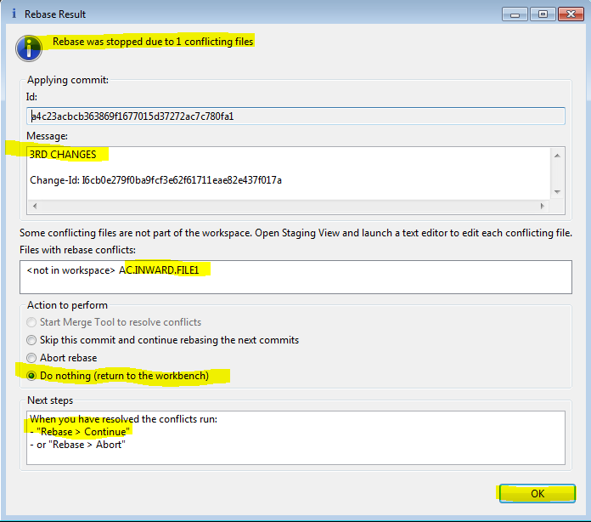

1. Next you can see conflict routines on unstaged changes, drag that routine to editing area and resolve conflicts

* Observe below screen shot
* You can see conflict indicating symbols

<<< Upstream based….

===========

>>>>>>>>>a4c2... 3RD CHANGEs

* above equal line code is latest ( remote changes) and below equal line code is your changes
* keep code which you want push to remote and remove remaining code and also remove conflict indicating symbol lines ( <<< upstream …, =====, >>> >>a4c2…..)

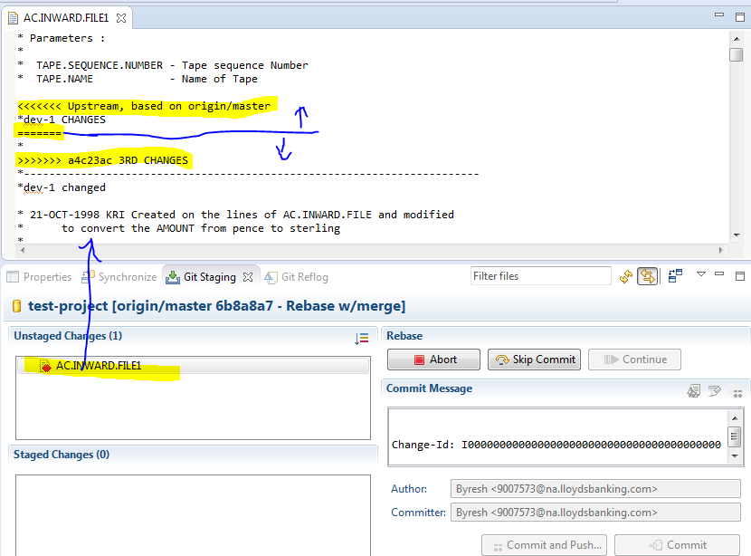

5 After resolving conflict save changes and drag to staged changes

* Click on Continue then click OK on popup window
* Then do refresh by clicking on refresh icon (see below screen shot)

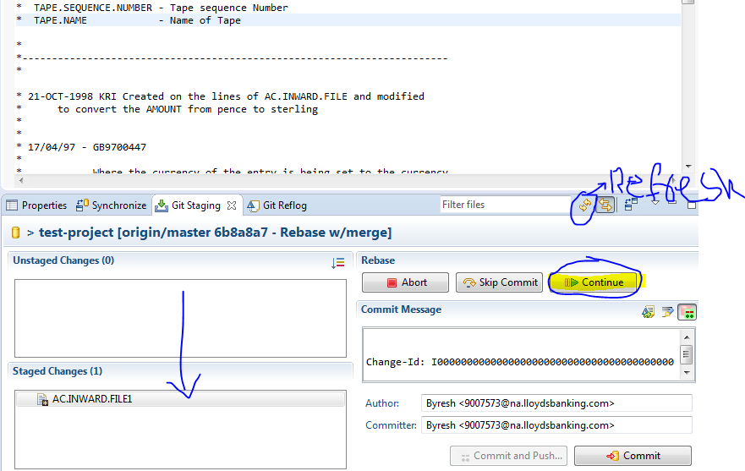

6 Next click on Amend (Edit Previous Commit) icon (see below screen shot)

* It will populate previous commit messages
* Then click on Commit and Push , click Finish and Ok on pop windows

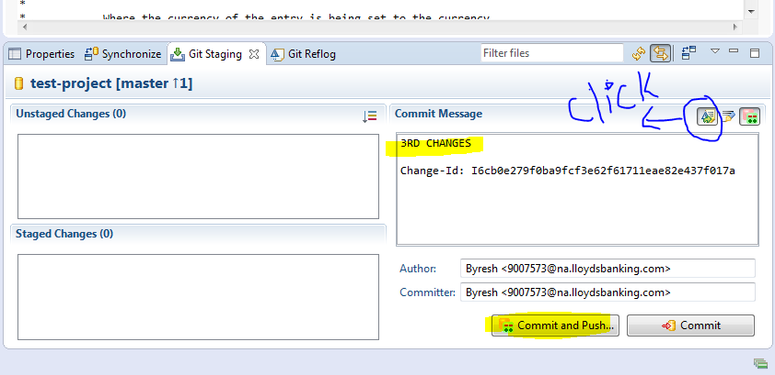

7. Now you can see in GERRIT, conflict is resolved

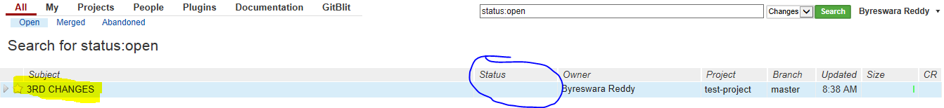

UPDATE LOCAL REPOSITORY USING FETCH AND REBASE (DON’T PULL) DOCUMENTATION [CLICK-HERE](http://teamspace.intranet.group/sites/IslandsIT/IRP/General/Devops/Git/UPDATE%20LOCAL%20REPOSITORY%20USING%20FETCH%20AND%20REBASE%20(DON%E2%80%99T%20PULL).docx)